**Question 1:**

Identify the main customer data.

This query collects key data needed to perform clustering.

select id, year_birth, education, marital_status, kidhome, Teenhome

from marketing_campaign

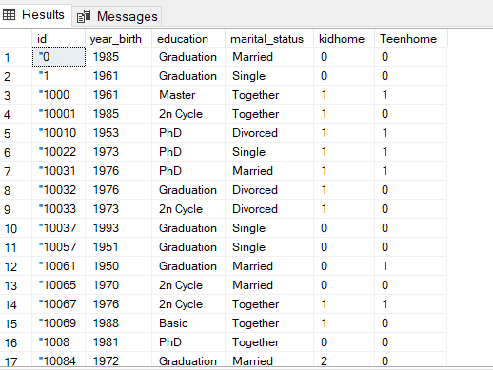

**Question 2:**

Analyze average spending by segment

This query collects the average spending on each category and shows the values of each, we can determine from them the most rated spendings in which category.

Select AVG(mntwines) as Average_Wine_Spend , AVG(mntfruits) as Average_Fruits_spend,

AVG(mntmeatproducts)as Average_Meat_Spend, AVG(mntfishProducts) as Average_Fish_Spend,

Avg(mntsweetproducts) as Average_Sweet_Spend, AVG(mntgoldprods) as Average_Gold_Spend

from marketing_campaign

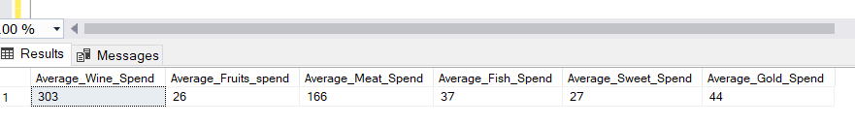

**Question 3:**

To identify which segments contribute most to our revenues, we calculated total spending based on marital status

Select Marital_Status, Sum(Mntwines + Mntfruits + Mntmeatproducts + Mntfishproducts + Mntsweetproducts + Mntgoldprods) As Total_Spent

From Marketing_Campaign

Group By Marital_Status

Order By Total_Spent Desc;

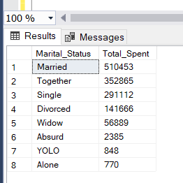

**Question 4:**

Analyze relation between complaints and total spending

SELECT Complain,

SUM(MntWines + MntFruits + MntMeatProducts + MntFishProducts + MntSweetProducts + MntGoldProds) AS Total_Spend,

COUNT(ID) AS Num_Customers

FROM marketing_campaign

GROUP BY Complain

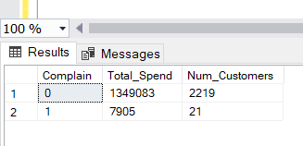

**Question 5:**

Identifying the most loyal customer demographic involves analyzing repeat purchases by marital status

SELECT top 1 Marital_Status, SUM(NumWebPurchases + NumCatalogPurchases + NumStorePurchases) AS Total_Purchases

FROM marketing_campaign

GROUP BY Marital_Status

ORDER BY Total_Purchases DESC;

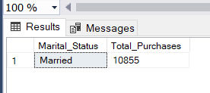

**Question 6:**

Determine how recency affects the total spending and customer loyalty

This query shows the relation and the effect of recency on the number of customers and their total spendings.

SELECT Recency,

SUM(MntWines + MntFruits + MntMeatProducts + MntFishProducts + MntSweetProducts + MntGoldProds) AS Total_Spend,

COUNT(ID) AS Num_Customers

FROM marketing_campaign

GROUP BY Recency

ORDER BY Recency ASC

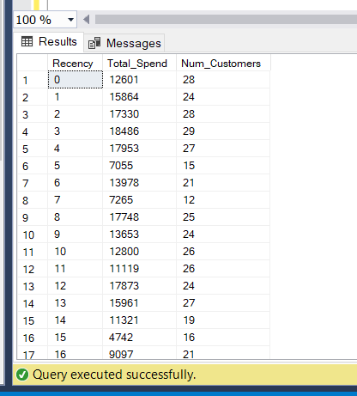

**Question 7:**

Analyze spending behavior based on family structure (Marital Status, Education)

SELECT Marital_status ,Education, AVG(Mntwines + Mntfruits + Mntmeatproducts + Mntfishproducts + Mntsweetproducts + Mntgoldprods) AS Avg_Spending

FROM marketing_campaign

GROUP BY Education , Marital_Status

ORDER BY Avg_Spending DESC;

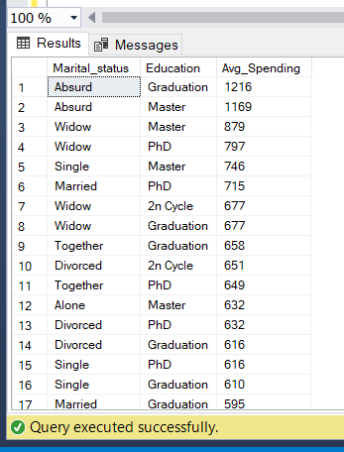

**Question 8:**

What percentage of customers have accepted at least one marketing campaign?

Select (Count(Case

When Acceptedcmp1 = 1 Or Acceptedcmp2 = 1 Or Acceptedcmp3 = 1 Or Acceptedcmp4 = 1 Or Acceptedcmp5 = 1

Then 1 End) * 100.0 / Count(*)) As Percentage_Accepted_Campaigns

From Marketing_Campaign

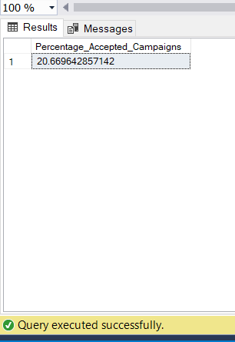

**Question 9:**

Identifying the most popular product categories gives us insight into where to focus our marketing efforts/ and the most popular product?

Select Top 3

'Wines' As Category, Sum(Mntwines) As Total_Spent

From Marketing_Campaign

Union All

Select 'Fruits', Sum(Mntfruits) From Marketing_Campaign

Union All

Select 'Meat Products', Sum(Mntmeatproducts) From Marketing_Campaign

Union All

Select 'Fish Products', Sum(Mntfishproducts) From Marketing_Campaign

Union All

Select 'Sweet Products', Sum(Mntsweetproducts) From Marketing_Campaign

Union All

Select 'Gold Products', Sum(Mntgoldprods) From Marketing_Campaign

Order By Total_Spent Desc;

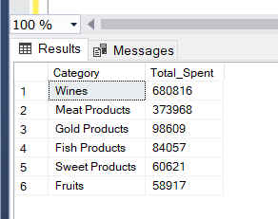

**Question 10 :**

Rank customers by total spending

This query will rank customers based on their total spending across all product categories.

SELECT ID , SUM(MntWines + MntFruits + MntMeatProducts + MntFishProducts + MntSweetProducts + MntGoldProds) AS Total_Spend,

RANK() OVER (ORDER BY SUM(MntWines + MntFruits + MntMeatProducts + MntFishProducts + MntSweetProducts + MntGoldProds) DESC) AS Spending_Rank

from marketing_campaign

Group by ID

